Brevity Care Software Manual

November 2018

Log in Screen

Login Screen page is where you will need to type your given username and password to access the application. After logging in, you will be directed to the application dashboard.
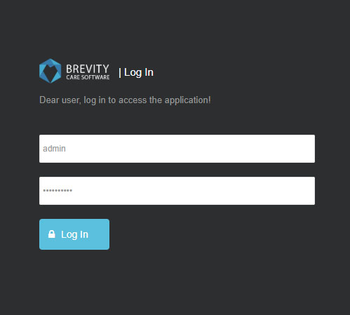

Image 1. Brevity Login Screen

Dashboard

Dashboard is the first point of contact in the application. It shows a quick preview all the information such as Quotes, Schedule Chart, Client funding and Alerts. In the quotes section, it shows the status of quotes that has been given to the customer and who is the responsible person for the quotes. Schedule Chart show the schedule of all the employees for the given date and the total number of schedules on that date. There is a quick summary of Past Services, Timesheet, Services and Invoiced Services that can be found in the upper right corner of the dashboard. Client Funding section shows the summary of all the clients fund. This portion can be used to quickly determine if there are clients that needs to update their funding expiration and balance. Alerts section shows if the employees has upcoming expiration like car insurance and driver’s license. This section could prevent issues within the employees and remind them to update their licenses.
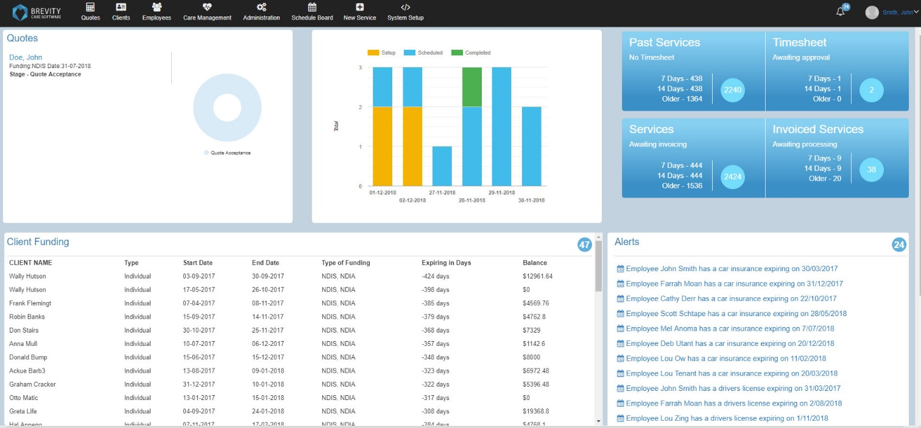

Image 2. Brevity Dashboard

Quick access panel
Quick access panel is used to browse the system. Clicking the Brevity logo will always direct you to the dashboard.

