Guide to using the Provider Supported Independent Living (SIL) Pack
September 2018

Overview

Background and overview
Participants with high support needs, who require assistance with daily life tasks to live as independently as possible, may require a Supported Independent Living (SIL) quote and assessment to be done, as part of their plan.
The SIL quote is completed by a provider, and takes into account the broad needs and goals of a participant requiring support to live more independently in their own home, or in group or shared accommodation.
The National Disability Insurance Agency (NDIA) is working closely with providers who work in this SIL space, and provides tools to help them cost supports and submit SIL quotes.
Based on provider consultation and staff feedback, the NDIA has updated the tools that help providers develop solutions for participants requiring SIL supports.
The Provider SIL Pack has been co-designed with providers and incorporates feedback collected over the last 12 months. It is user friendly, more efficient, flexible, and removes duplication of effort through simple automation.
The new Provider SIL Pack contains the following documents/templates:
- Provider SIL Quoting Template
- Provider SIL Quoting Tool
- Provider SIL Quoting Tool Examples
- Guide to using the Provider SIL Pack (this document)
- Subsequent SIL Quote Template

Benefits of the new Provider SIL pack:
Greater efficiency
Quotes are able to be processed in a much more timely, consistent and effective manner. Duplication of work is also reduced through simple automation.

Greater flexibility
The new Provider SIL Pack allows for much more flexibility. Among other things, providers are now able to specify overnight information, cross-over shift information, and choose their own ratios of support.

Fewer delays
Through the introduction of the new Provider SIL Pack providers will experience fewer delays in getting their SIL quotes approved.

Contents

Contents
Overview 1
Contents 2
The SIL quoting process 3
The provider SIL quoting template 5
The provider SIL quoting Tool 8
Submitting your quote 15
Reasonable & necessary decisions 16
Frequently Asked Questions (FAQs) 17

The SIL Quoting Process

SIL quoting process
Providers follow the following process when quoting for SIL:
- develop the quote using the Provider SIL Quoting Tool
- complete the SIL Quote Template
- complete the Subsequent SIL Quote for participants who require the same SIL Support as their previous plan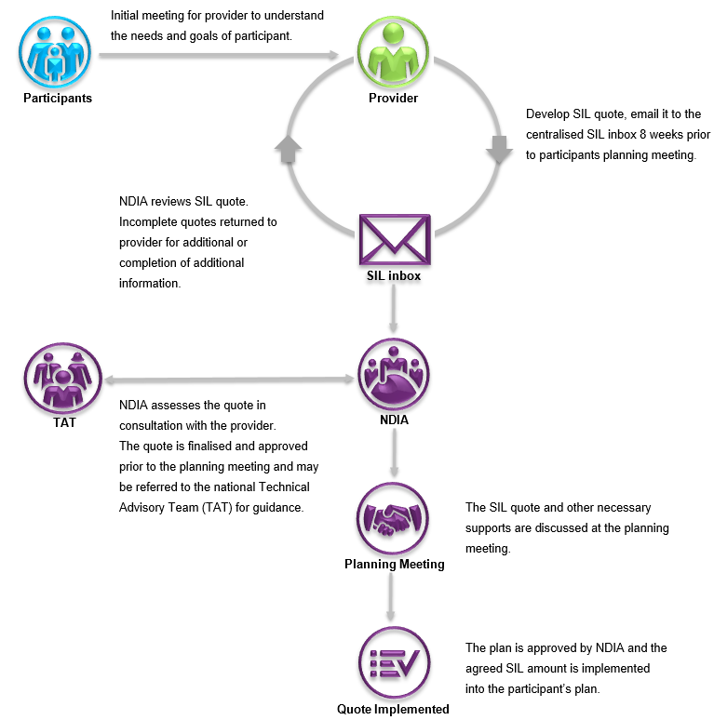
Quote Agreed
Submitting your SIL quote for assessment (subsequent quotes)
To assist with streamlining of subsequent quotes for SIL participants, an additional template has been introduced. For participants who require the same SIL support that was included in their previous plan, providers need only submit the Subsequent SIL Quote for approval.
The additional template is easy to complete, consisting of just two pages and means providers are not required to submit the usual templates in the Provider SIL Pack. This is to be used in situations whereby participants support needs have not changed, compared to the prior year’s quote.
If there was an expectation of supports being reduced or capacity increased, a full SIL quote is required.
The additional template enables the provider to submit the previous year’s SIL quote amount, allowing for indexation adjustments.

The Provider SIL Quoting Template

Overview of each section in the Provider SIL quoting Template
The Provider SIL Quoting Template is divided into seven sections, each section providing different information.
- Quoting Guidelines – to provide an overview and guidance regarding the requirements and considerations for completing the template.
- Participant Profile – including participant details, goals, needs, and the supports they may require.
- Property Profile – describes the property the participant will be living in, including who they will be sharing with.
- Participant Outcomes – gives the desired outcomes for the participant and any outcomes that were successfully achieved in the prior year (if applicable).
- Quote – details the proposed quote and the weekly unit cost.
- Quote Exclusions – items to be excluded from the SIL quote but necessary to show the overall services and support the participant is receiving. These items may be funded elsewhere under the NDIS (e.g. transport) or not funded at all (e.g. rent).
Attachments – for any information that will need to be attached as part of your quote in order for your quote to be processed in a timely and consistent manner
Guide to completing the Provider SIL Quoting Template
The quoting template gives NDIA a snapshot of the participant, their needs, their capacity, and their goals.
When completing the Provider SIL Quoting Template, use succinct, specific and relevant statements that will enable a NDIA to make a reasonable and necessary decision. It is important that you provide any information that you think would be useful in making a decision about the funding requirements of a particular participant.
Step 1: Complete the Participant Profile section

Participant profile information | Participant profile descriptor
Participant name | Provide the participant’s full name
NDIS participant number | Provide the participant’s NDIS number
Participant date of birth | Provide the participant’s date of birth in dd/mm/yy ( numerical date month year) format
Participant level of support | Based on your knowledge of the participant, provide their current support needs level based on the criteria in the NDIS price guide (i.e. Low/Standard/High)
Participant goals | List and describe the participant’s goals in relation to independent living (E.g. the participant might like to learn how to cook, or dress themselves.)
Participant’s disabilities | List all of the participant’s disabilities and conditions

Participant profile information | Participant profile descriptor
Current behaviours of concern | List and describe all the behaviours of concern, including the frequency. Provide examples and any strategies that are in place to address/minimise these behaviours.
Participant’s current support needs | List and describe the participant’s current support needs (e.g. requires assistance with personal support and hygiene, requires assistance with feeding.)
Participant’s support needs history | This gives providers the opportunity to describe the support needs history of a participant and the work they have done with that individual
Participant informal and other supports | List and describe the current informal and other supports being provided to a participant. (e.g. attending a day program, family visits, etc.)
Participant mainstream supports | List and describe any mainstream supports required or accessed by the participant (e.g. doctor appointments, dialysis, etc.)
Participant decision maker | Name the person responsible for making decisions on behalf of the participant (e.g. mother, father, guardian)

Step 2: Complete the Property Profile section
Property profile information | Property profile descriptor
Property address | Provide the participant’s address in which SIL is provided
Number of bedrooms | Enter the number of bedrooms in the property in which SIL is provided
Number of dwellings | Enter the number of dwellings on the property (e.g. 2 x townhouses)
Home modifications or assistive technology | List any home modifications or assistive technology such as ceiling hoists, ramps, etc.
Number of NDIS participants living at the property | Provide the number of NDIS participants living at the property or dwelling
Number of non-NDIS participants living at the property | Provide the number of non-NDIS participants (e.g. people over the age of 65 not eligible for the scheme) living at the property or dwelling who are sharing support with the NDIS participants
Name(s) of other NDIS participants sharing | List the full names of other NDIS participants who are sharing with this particular participant. This is to ensure participants are not missed

Step 3: Complete the Participant Outcomes section
- Proposed capacity building outcomes: detail the proposed capacity building outcomes for the participant, describe how they will be measured and describe what success looks like.
Example of proposed capacity building outcome:
Outcome | How will this be measured | What does success looks like
Participant would like to learn how to cook | Number of meals prepared each week | Participant cooks for all residents on a Thursday night whereby family is invited to join

- Prior year capacity building outcomes achieved: if applicable, detail the capacity building outcomes that were achieved in the prior year.
Example of prior year capacity building outcome:
Outcome | How will this be measured | What does success looks like
Participant would like to learn how to cook | Number of meals prepared each week | Participant has learnt to cook and prepares on average 2 meals per week. This includes a weekly meal whereby all residents and family are invited.

Step 4: Complete the Quote section
- SIL quote amount excluding indexation: the weekly SIL amount which excludes indexation.
- Indexation percentage (%): the new Provider SIL Pack allows providers to specify the indexation percentage (%) to be applied to their SIL quotes, to cover expected higher wages for support workers in the period post 1 July 2019. This indexation percentage should be an estimation of award wage growth, including the Equal Remuneration Order (ERO) adjustment for support workers using the Social, Community, Home Care and Disability Services Industry (SCHADS) Award. As a guide, NDIS prices have increased by an average of 4.51% over the past three years. This indexation amount will automatically be included by the Agency.
Step 5: Complete Quote Exclusions section
- Consider the exclusions listed and ensure your quote does not include costs for these items.
Step 6: Complete Attachments section
- Ensure all required attachments and additional information has been completed and submitted with this document. This will allow your quote to be able be processed in a more efficient, consistent and timely manner.
- In submitting additional information or assessments, ensure all documents are relevant and current. If for example, a participant is receiving 1:1 support due to behaviours of concern, NDIA would expect information regarding those behaviours. The quality and relevancy of information is preferred over quantity of information. See SIL quote template for a list of examples.
It is important to provide contact details of the person who completes this document so that NDIA can obtain further information or seek clarity on certain aspects.

The Provider SIL Quoting Tool

Purpose
The Provider SIL Quoting Tool allows NDIA to get insight into a typical week for each SIL participant. Specifically, the tool aims to provide a mechanism for providers to communicate a participant’s quote with the Agency. This tool will detail the staffing mix, the level of shared supports, as well as their individual needs. NDIA will be able to see the levels and variability of support and the informal support that is provided on a weekly basis.
Together the Provider SIL Quoting Tool, the Provider SIL Quoting Template and any supporting documentation should be sent to the centralised SIL inbox for allocation of assessment and review.
The Provider SIL Quoting Tool combines Roster of Care and Hourly Breakdown spreadsheets into one spreadsheet called Hourly Breakdown and automates the calculation of weekly summaries. This should in turn:
- reduce duplicate information provided to the Agency
- improve accuracy of information shared between NDIAs and providers.
Shift type definition
The Hourly Breakdown summarises the supports to be provided to participants during different shifts / rates as defined below:
Shift type | Description
Mon-Fri (6am-8pm) | Weekday hours between 6am to 8pm where participant requires SIL support, excluding participant sleeping time and crossover afternoon/evening shifts. During these hours, the weekday daytime rate applies.
Mon-Fri (8pm-12am) | Weekday hours between 8pm and 12am where participant requires SIL support, including crossover afternoon/evening shift starting before 8pm and excluding participant sleeping time. During these hours, the weekday evening rate applies.
Saturday & Sunday | This includes hours on Saturday or Sunday where:  - Participant is awake and requires SIL support; and  - Active overnight shift hours.  During these hours, Saturday or Sunday rates apply.  Note: Active overnight shift hours are included as these shifts are paid at the Saturday / Sunday rates. Sleepover shifts are captured under ‘Sleepovers’.
Sleepovers | This is calculated as the number of nights per week when a participant requires sleepover support, including weekends.
Active overnight shift (Mon-Fri) | These are the number of hours per week between Monday and Friday where active overnight shifts are required. This excludes active overnight shift required on weekends.
Public holiday | The number of public holidays per year where a participant requires SIL support.
Irregular support | The number of days per year where a participant requires unplanned irregular SIL support.

Guide to completing the Provider SIL Quoting Tool
Step 1 – Fill in Overall Information
This tool is an excel file with tabs along the bottom. Relevant section will need to be selected according to the stages listed below.

Step 1.1 – Enter overall details
- SIL property address;
- Maximum number of support staff at the residence at any given time:
- Indexation % to be applied. Please choose one from the drop down list.
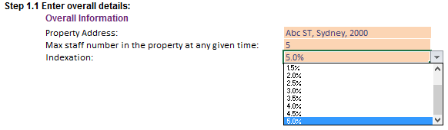
Step 1.2 – Enter participant details:
For each participant:
- Enter his/her name in “Participant Name” column. Please include all non-NDIS residents. To respect the privacy of non-NDIS residents, please list non-NDIS participant information by entering Non-NDIS A, Non-NDIS B. It is important that all residents in the dwelling are captured when considering the staffing levels;
- Choose from the drop down list if the participant is a NDIS participant or not.
- Choose from the drop down list each participant’s needs level;
- Enter quote’s effective date from, in the format of dd/mm/yyyy, e.g. 31/01/2018;
- Enter your estimated weekly quote amount excluding indexation for each participant in “Weekly Quote ($)” column.
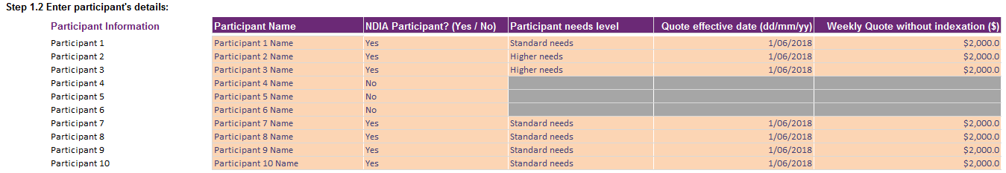
Note: If you have more than 10 residents living at the property, please use more than 1 SIL Tool. For example, the first SIL Tool will contain information for 10 residents and the second SIL Tool will contain information for the remaining residents.

Step 1.3 (Optional) – Enter your hourly rates for the quote
Enter your hourly rates and an estimated SIL amount will be calculated (step 3.4) based on the hours of support provided to that participant. Feel free to delete these rates prior to submitting to the NDIA. See section 3.4 for more details. For the difference between Lower, Standard and Higher needs, please refer to the FAQs in this document.

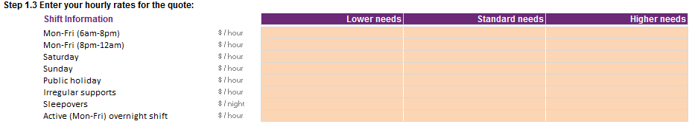

Step 2 – Fill in Roster of Care (ROC)
The Roster of Care should reflect the high level staffing arrangements and the level of supports to be provided to participants (i.e. the ratio of support) in the home for a typical week.
The purpose of this spreadsheet is to capture what a typical week looks like in terms of supports required. Irregular supports (i.e. unplanned or unexpected supports) are not considered typical and therefore are captured later in the process.

Step 2.1 – Review and fill in the support ratios in the legend
Support ratio is the staff to participant ratio which reflects the staffing arrangement for the participant.
By default, the Tool has two fixed support ratios (left circle below) which cannot be changed. If you require other support ratios, 19 placeholder ratios have been provided (right circle below). Simply select the desired support ratio from the drop-down selection. If the desired ratio is not in drop down list, please choose the ratio that most closely matches your desired ratio and describe this in the notes section of the Roster of Care.
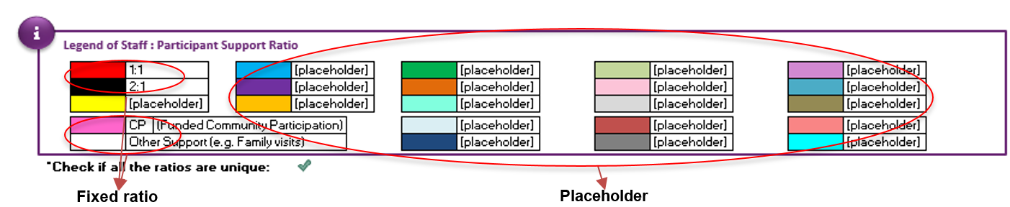
To select a ratio, click on [placeholder] and a drop-down arrow will appear as below. Click on the arrow and select the appropriate ratio from the drop-down list
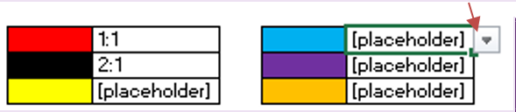
Ensure that there is a green tick below the legend. This checks that all the ratios in the legend are unique and there are no duplicates. If the check displays a red cross, please change the duplicated ratio to ensure that all legend ratios are unique.
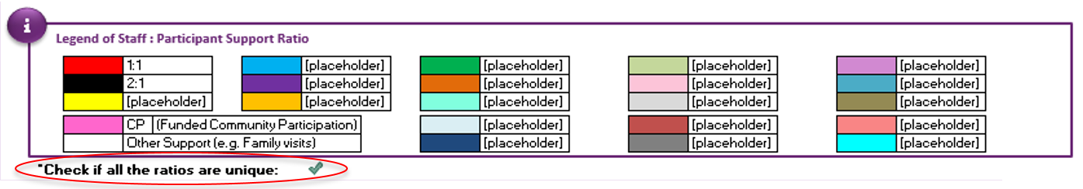

Step 2.2 – Complete the roster using the required ratios
Click on any cell in the roster and a drop-down list will appear. This drop down list contains all inputted ratios you have entered. Select the appropriate ratio. Each block represents a half hour (30mins).
Where a participant does not receive SIL support, the Tool differentiates between community participation hours and other support (including informal support). For funded community participation hours (if known), select ‘CP’ from the drop down list. For other support such as family visits or other informal support, please leave the cells blank (white).
To simplify the data entry process, you can ‘copy and paste’ ratios across participants and shifts. However, please do not ‘cut and paste’ ratios. This will interfere with the Tool’s calculations, resulting in errors.
If you have accidentally ‘cut and paste’ a ratio, please undo the action (Ctrl + Z) or start again with a blank Tool.
A warning will appear to alert the user if they have accidentally cut and paste.
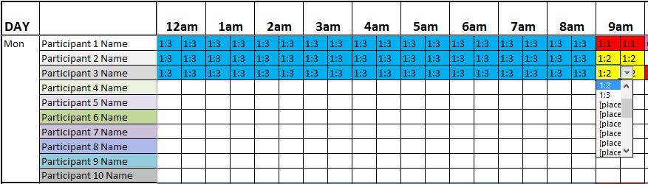

Step 2.3 – Fill in the Overnight Support and Afternoon / Evening shift details
To complete the Overnight Support Information, go to the ‘Overnight shift’ column and select ‘Active overnight’ or ‘Sleepover’ from the drop-down list embedded in.
Subsequently, select the sleep start and end time in the next two columns respectively. If the participant doesn’t have any overnight support on a particular day then please select ‘None’ from the drop-down list or simply leave it blank.
To complete the Afternoon / Evening Shift information (also known as a cross over shift), select ‘yes’ or ‘no’ in the ‘Does the [afternoon / evening] shift start before 8pm?’ column. If you have answered ‘yes’, please select the ‘Average shift start time’ and ‘Average shift finish time’ for that particular shift from the drop down list.
Cross over shifts should be used when a particular shift crosses over from one shift to another (e.g. from afternoon shift to evening shift). Where there may be multiple cross over shifts starting at different times, please use an average shift start time from the drop down list . If you are unsure which participants are receiving cross-over shift supports, then you may allocate the cross-over shift across all participants
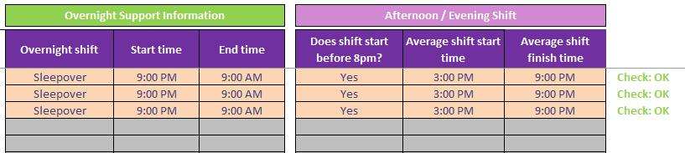
Step 2.4 – Solutions to fix invalid checks
Checks have been built into the Tool to ensure that the data entered is valid. When these error messages appear, please resolve them as follows:
- “There are duplicate ratios in the legend.” – This indicates that there are two or more of the same ratio in the legend. Please go back to the legend (step 1.3) and review all ratios to ensure they are unique.
- “Information provided is incomplete.” – This indicates that the roster has been populated for the specific participant, however the Overnight Support Information and/or Afternoon / Evening Shift Information (in Step 1.5) has not been completed. The fields that need to be completed are shaded orange. Please ensure all orange cells are completed.
- “Start or finish time has not been completed.” – This error indicates that either the ‘Sleep start / finish time’ or ‘Average shift start/finish time’ has not been completed. Please select them from the drop down list.
- “No overnight support - crossover shift should finish no later than 12am.” – If the participant doesn't have overnight supports on a particular day, the crossover shift should finish no later than 12am.

Step 2.5 – Review summary of total number of staff
Based on the roster of care you have entered, a summary of the total number of support staff in the property or dwelling (per half hour) has been provided at the bottom of this sheet.
If the total number of hours is not a whole number (e.g. 0.7), the cell will be highlighted in red for you. Please review this section and make any necessary changes if required.
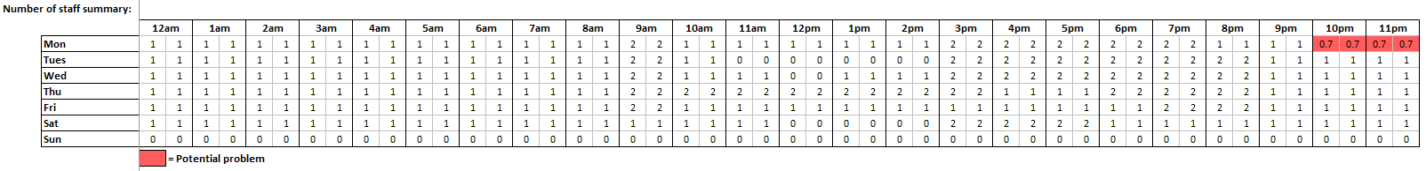

Step 2.6 – Add any notes that will assist the NDIA’s understanding of the roster
For example:
- Regular/scheduled time spent with family and/or friends
- Regular or scheduled appointments (i.e. doctor, dentist and specialist appointments)
- Transport to or from work and/or community participation activities
- Attendance at work or other programs and/or services
- Rationale for irregular hours (e.g. the number of days at home during last 6-12 months)
- Handovers should be included and the time should be divided by the relevant number of residents in the house, at the relevant staff ratio
- Any information that may assist the NDIA in understanding the roster of care
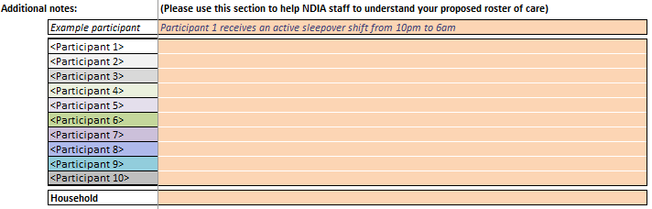

Step 3 – Review and complete the SIL Hourly Breakdown sheets
Select the sheet for the participant you are quoting for.
Step 3.1 – Review the Hours of Support Summary
This section summarises the hours of support by shift and support ratio, based on the roster of care data entered in Step 1. Please review to ensure correctness.
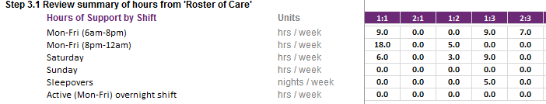

Step 3.2a (Optional) – Adjust the Hour of Support Summary
If the summary in Step 3.1 requires adjustments to be made, please adjust the hours in this section by typing the appropriate number of hours by shift and support ratio in the relevant cell.
You don’t need to make any adjustment if it’s relating to Crossover Shift (Afternoon / Evening Shift) as the tool takes that into consideration.
The number you enter will not increase or decrease the hours in Step 3.1 by that amount, instead it will overwrite the hours in step 3.2b (e.g. If you have put down 5 hours in sleepover shift under 1:1 support ratio, the total number of hours that the participant is receiving for 1:1 support will become 5 hours).
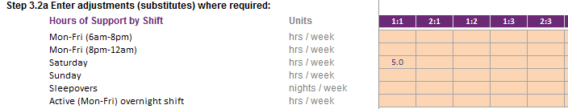
Note: Please also include the reason for the adjustment.

Step 3.2b (Optional) – Review the Hours of Support Summary after adjustments have been made
Review the Hours of Support Summary for the adjustments made in Step 3.2a. If more adjustments need to be made, repeat Step 3.2a.
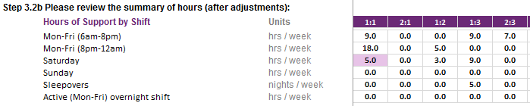
Note: overwritten hours # will be highlighted in purple as above.
Ensure all checks are green:
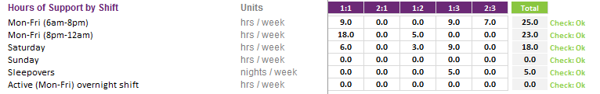
Please refer to the table below for the maximum time permitted per week for each shift type.
Shift type | Max time allowed | Unit
Mon-Fri (6am-8pm) | 70 | Hours / week
Mon-Fri (8pm-12am) – excluding cross over shifts | 20 | Hours / week
Saturday | 24 | Hours / week
Sunday | 24 | Hours / week
Sleepovers | 7 | Nights / week
Total hours per week | 168 | Hours / week

Step 3.3 – Enter number of days per year for the Public Holidays and Irregular Supports
Enter the number of public holidays and irregular supports days per year where a participant requires SIL support. Please enter the days per year and the Tool will automatically calculate the average weekly hours in the final summary (Step 4).
Public holidays are calculated as 24 hour days.
Irregular support days are calculated as 16 hour days.
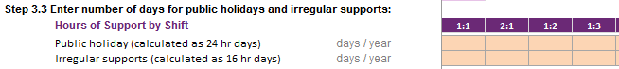

Step 3.4 - Review the estimated SIL amount for the selected participant
The estimated SIL amount is calculated automatically based on the hourly rates you entered (step 1.3) and the hours of support to be provided.
Please note that the amount shown in the “Estimated annual SIL amount” is an estimate only and should be used as a guide only. It is subject to Agency review and reasonable and necessary decision making processes. The hourly rates you entered in step 1.3 is optional and may be deleted before submitting to the NDIA.

Step 3.5 – Review Hours of Support Summary
The Hours of Support Summary is available at the bottom of the page for you to review.
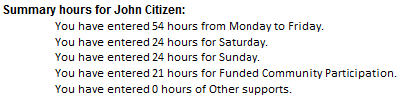

Step 4 – Review the Final submission
Step 4.1 – Choose the participant you are submitting for
Select the participant’s name you are submitting for from the drop-down list

Step 4.2 – Review the final summary for completeness, accuracy and reasonableness
Please review the final submission page. Before submitting any templates (or evidence) to the NDIA, ensure that you have reviewed the information for completeness, accuracy and reasonableness.

Submitting your quote

Submitting your SIL quote for assessment (New quotes or for change of circumstances)
Prior to submitting your quote, please ensure the following:
- participants or their families/guardian have been consulted regarding the proposed service offering
- all templates and tools have been completed
- only use NDIA templates and tools to avoid delays in quote assessment
- the quote does not include items that are not funded under the NDIS, or items that are funded outside of SIL – e.g. employment supports, therapy, etc.
- include any additional information or assessments that would assist in the understanding of the participant’s needs or the required supports.
To submit your quote along with any required information, please email the national SIL inbox SIL@ndis.gov.au .
Quotes should be submitted 6 - 8 weeks prior to plan review.

Reasonable & necessary decisions

Reasonable and necessary
NDIA is required by legislation to make funding decisions that are deemed to be reasonable and necessary. In determining reasonable and necessary, the following criteria must be met:
- it will enable the participant to meet their goals and objectives
- it will assist the participant’s independence, social and economic participation
- it represents value for money both in terms of the benefits achieved and the cost of alternative support
- it is effective or beneficial for the participant having regard to current good practice
- it must coordinate with but not replace informal support
- it is most appropriately funded by the NDIS
- it must relate to the person’s disability
- it’s not likely to cause harm to the participant or pose a risk to others
- it is not duplicating other supports delivered under alternative funding
- it does not relate to day-to-day living costs that are not attributable to a participant’s disability support needs

Therefore, when submitting your SIL Pack and any evidence, ensure the information is sufficient to allow NDIA staff to make a reasonable and necessary decisions according to the above criteria.

Frequently Asked Questions (FAQs)

General – FAQs:
- Why the new templates?
- The new Provider SIL Quoting Template and Provider SIL Quoting Tool has been introduced as a response to provider and staff feedback. The new templates have been co-designed with providers and NDIA staff. It reduces administrative burden through automation, is more flexible, is easier to use, and improves the efficiency of the quoting and assessment process.

- Can I still use the old templates?
- Yes. The old templates will continue to be accepted by the Agency until the end of 2018.

- What happens if I do not follow the national SIL quoting process?
- All quotes must be submitted using he national SIL Quoting template. If not, your quote will be returned requesting you to resubmit your quote using the national provider SIL pack.

- Where do I go for support on the SIL quoting process?
- The new Provider SIL Pack is designed to be intuitive and promote self-service. If upon review of this training guide and FAQs you require further support in completing the new SIL quoting process, contact SIL@ndis.gov.au.

Q. What supports/costs are included in SIL?
- SIL reflects the supports delivered to individual or groups of participants (sharing support staff) in the home, usually for 53 weeks. It also includes supports delivered outside of the home whereby participants are undertaking everyday activities (e.g. grocery shopping, going out for a meal, attending doctor or medical appointments, going for a walk) and support with using transport to participate with community or informal supports (vehicle costs should be excluded).

Supports should also be included in the SIL quote where it would not be practical for an alternative provider to deliver those supports (e.g. the activity is not structured nor predictable)

- What supports/costs are excluded from SIL?
- Generally, everyday living expenses (such as rent, utilities, groceries, entertainment expenditure, etc.) are excluded from SIL.

Other NDIS funded supports (such as transport, therapy, employment support, etc.) should also be excluded from the SIL quote as these items are funded (if participant is eligible) outside of SIL. Where a participant has identified that they are attending or would like to engage in community activities, providers should detail this in the Provider SIL Quoting Tool’s Roster of Care’ worksheet. This may be funded under Core Supports by the NDIA depending on reasonable and necessary decision making.

In regard to community participation activities, the NDIA may determine that certain activities should be funded as part of SIL rather than funding separately under Core Support budget. It depends on the duration of the activity and whether another provider can reasonably be expected to provide that service. The duration of the activity is important as it would not be cost effective or realistic to expect an alternative provider to deliver supports to a participant for a 30 minute walk, for example.
SIL quotes should not include supports when a participant is absent from the residence for an extended period of time (e.g. hospitalisation or holidays). Similarly, if a participant is known to be away for periods at a time (e.g. regular hospital visits or staying with family), the provider can include a higher staff ratio for the shared support component in the other residents’ quotes for those periods. This will be a case by case situation and supporting evidence will be required.

As SIL supports are a stated support, participants cannot use SIL funding for other purposes (e.g. holidays or associated travel costs).

If the participant is required to cover these excluded costs (outlined above) using their personal funds, the provider will need to discuss this separately with the participant, as NDIA will not cover the cost of daily living expenses. The cost should be negotiated and included in the Service Agreement, or similar.

- Under what circumstances should a participant request a plan review?
- If there is a change of circumstance whereby a participant’s support needs have significantly changed, resulting in the SIL provider needing to increase supports or change the roster of care to accommodate the change in needs, then a participant can request a plan review through a the Change of Circumstances process. For example, there has been a change in the participant’s living situation, and the change presents a risk to their safety and well-being.

- What should I do if a participant goes on holiday?
- The Agency funds a maximum of 53 weeks SIL support annually. Any holiday arrangements and the claiming of funds during that period need to be negotiated between participants (or person responsible) and the provider. These arrangements should be mutually agreed and should also be included in the Service Agreement.

- Does the Agency fund vacancies? How should I manage my vacancies?
- The Agency is not responsible for vacancy management. This is the responsibility of the relevant provider. Generally, vacancies will be planned and a period of notice should be mutually agreed between both parties and included in the Service Agreement. Given the time a participant needs to find alternative accommodation and for a provider to fill a vacancy, a 12 week notice period is suggested.
Where there is a change of circumstances (significant change in a participant’s support needs), contact should be made with NDIA regarding the ability to maintain critical supports.

- What are some common reasons why quotes are rejected/require re-submission?
- Reasons for rejection include:
- no evidence or out of date evidence submitted
- missing templates (most commonly the Provider SIL Quoting Template)
- missing notes on the roster of care
- providers sending their own version of the tools (or PDF versions)
- including too many hours per week
- missing information such as quote amount, participant outcomes, etc.
- participants not being consulted during the process

- Does the NDIA have a size limit regarding emails?
- Yes, emails that exceed 20MB will be quarantined and may take time to be released. Consider compressing files or dividing files into separate smaller sized emails.

- Definition for Lower needs, Standard needs and Higher needs?

Lower needs:
- This support provides supervision of living arrangements as a whole including occasional to intermittent prompting to undertake household tasks and/or self- care activities:
- Supervision is not usually provided 24/7, supervision may be provided via off-site monitoring if appropriate
- If the participant has had incidents of challenging behaviour, a behaviour support plan is in place and it is demonstrated that the participant can be supported effectively within the available support
- Where a participant has additional support needs, they may be supported in this living arrangement through a mix of additional paid and informal supports

Standard needs:
- This support provides 24/7 support which includes:
- Active assistance or supervision of most daily tasks
- Regular inactive overnight (sleepover)
- Participants may be able to spend some time with their family or a friend without paid support and may call on them for incidental assistance or companionship
- If the participant has episodic or occasional challenging behaviours there is a behaviour support plan in place which has been demonstrated to effectively support the person within the available support

Higher needs:
This support provides highly frequent (at least 1 instance per shift) assistance to the individual where features such as:
- Managing challenging behaviours that require intensive positive behaviour support;
- Continual, active assistance with all daily tasks;
- Active management of complex medical needs such as ventilation;
- Active support is provided 24/7 usually with an active overnight shift;
- Inactive overnight sleepover may be included as an exception, for example when family or friends sleepover;
- May include higher staffing ratios at peak periods, for episodic or incidental behaviour supports, or emergency medical needs (e.g. seizure management or discharge from hospital)

Provider SIL Quoting Template – FAQs:
- Do I have to use the Provider SIL Quoting Template for submitting my quote?
- Yes. Using this template will ensure your quote is processed in a timely and consistent manner. However, you may choose to use your own branding and colour scheme.

- What is meant by irregular supports and how do I determine the number of days?
- Irregular support relates to support that is provided in unexpected or unplanned circumstances. For example, if a participant cannot attend their day program due to illness or if a family stay has been cancelled. This is an estimate based on the provider’s knowledge or expectation regarding the need for irregular support (the estimation can also be based on the historical data if available). Additional evidence may be required if irregular support is significant (i.e. greater than 20 days per year).

- How do I determine the number of public holidays per year?
- This varies and is dependent on your state or territory. The number of public holidays quoted should reflect the number of days whereby SIL support staff are paid at public holiday rates. As an example, if a participant goes home for 5 public holidays per year then you would subtract 5 days from the total number of public holidays for the year.

- Some sections don’t apply to me or my participant, what should I do?
- You may leave those sections blank or alternatively, provide a statement as to why that particular section does not apply. However, not providing a statement may result in an Agency staff member contacting you to clarify if it was an omission or as intended. Therefore, we suggest writing “Not Applicable because...” to avoid any confusion.

- I have been asked to submit further evidence or information, why is that?
- NDIA staff have to make reasonable and necessary decisions under legislation and on the basis of information and evidence available to them. If this is insufficient, they may require additional information from you.

If a participant requires a higher level of support, please ensure you have provided sufficient information for NDIA to make a reasonable and necessary decision. For example, feeding, transfers, incontinence support, etc.

When submitting further information or evidence, please reference relevant attachments or cite the relevant section/page number of evidence so that the NDIA can refer to them directly and efficiently. (E.g. two person transfers is recommended in the OT report on page 6).

Ideally, information and evidence should be dated within the last 2 years, however in the absence of anything more current, submit documentation if it still relevant, indicating why it is still relevant. Identify the need for and benefits of additional funded supports to build participant capacity and/or independence (e.g. assessment for assistive technology or functional behaviour assessment for participants to develop coping strategies to self-regulate behaviours).

Provider SIL Quoting Tool – FAQs:
- Do I need to complete the Provider SIL Quoting Tool when submitting a quote?
- Yes. Completing this spreadsheet not only ensures that your quote is processed in a timely and consistent manner, but also helps the NDIA understand the level and mix of support to be provided to participants.

- Do I need to complete this spreadsheet for each participant?
- No. The provider completes one spreadsheet per property, which includes all participants living at the property.

- The spreadsheet only caters for 10 participants, what should I do if there are more participants?
- In this instance, the provider should use additional Provider SIL Quoting Tools.

- What is meant by other or informal support?
- Other support relates to supports that are not related to SIL such as family visits, family stays, time spent with friends, mainstream supports, etc.

- A participant goes home to family on weekends every fortnight. How should I capture this?
- The provider should average the hours for the two weeks. See example below:
- Week A – Jane Doe receives 16 hours of support on a Saturday and 20 hours of support on a Sunday.
- Week B – Jane Doe receives no support on Saturday and 4 hours on Sunday.
- Therefore, the provider would enter the following hours of support in the roster; 8 hours (16 plus 0, then divided by 2) of support for Saturday, and 12 hours (20 plus 4, divided by 2) of supports for Sundays.

- What is the difference between active overnight shifts and sleepovers?
- Active overnight shifts are an awake shift (support worker stays awake while participant sleeps or during normal sleeping hours), which may be required due to the nature of the participant’s disability. Sleepovers are when the support worker stays the night and is allowed to go to sleep – however, they still may be required to provide support if needed (e.g. participant needs to use the bathroom, requires medication).

- Does the spreadsheet calculate a price for me?
- The Provider SIL Quoting Tool allows you enter your hourly rates and based on information provided in the Roster of Care, an estimated SIL amount (subject to reasonable and necessary decision making) is calculated for you automatically. Please note that you can delete these hourly rates before submitting to the NDIA as these rates are only used so that the provider can get an indication of the estimated SIL amount.

